Life in Cordoba
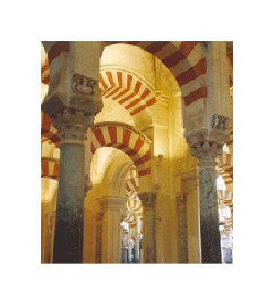
Cordoba, European Jewel of the Middle Ages
At a time when London was a tiny mud-hut village that "could not boast of a single streetlamp" (Digest, 1973, p. 622), in Cordoba "there were half a million inhabitants, living in 113,000 houses. There were 700 mosques and 300 public baths spread throughout the city and its twenty-one suburbs. The streets were paved and lit." (Burke, 1985, p. 38) The houses had marble balconies for summer and hot-air ducts under the mosaic floors for the winter. They were adorned with gardens with artificial fountains and orchards". (Digest, 1973, p. 622) "Paper, a material still unknown to the west, was everywhere. There were bookshops and more than seventy libraries." (Burke, 1985, p. 38).
Muslim scholars served as a major link in bringing Greek philosophy, of which the Muslims had previously been the main custodians, to Western Europe
There were 800 public schools
Cordoba was, indeed, the city destined to remain during Islamic rule, the literary centre of the Middle Ages, ‘the school of polite manners, the home of science and arts; to be regarded with awe by every Moslem, with affectionate veneration by every scholar, and with mingled feelings of wonder and apprehension by the turbulent barbarians of Western Europe.
المجموعة الأولى up
*صفوان الشوفي دعاء الشوفي شروق الشوفي
ندى جمول*


