The Arts in the Medieval Spain
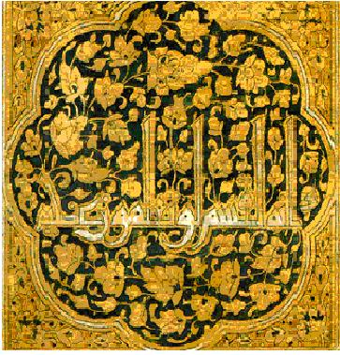
One area where the genius of the Muslim civilization has been recognised worldwide is that of art. The artists of the Islamic world adapted their creativity to evoke their inner beliefs in a series of abstract forms, producing some amazing works of art. Rejecting the depiction of living forms, these artists progressively established a new style substantially deviating from the Roman and Byzantine art of their time. In the mind of these artists, works of art are very much connected to ways of transmitting the message of Islam rather than the material form used in other cultures. This article briefly examines the meaning and character of art in Islamic culture and explores its main decorative forms-floral, geometrical, and calligraphic. Finally, it looks at the influence of the art developed in the world of Islam on the art of other cultures, particularly that of Europe.
The arts included beautiful calligraphy and painting. Arabs made glass objects and taught glassmaking to Europe. They also taught Europeans new techniques for working with wool, silk and cotton. Islamic Spain was famous for papermaking.
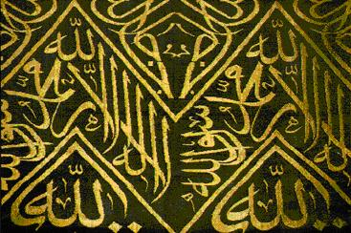
المجموعة الرابعة up
غنوة الشوفي
مجد المنعم
مهاب الشوفي
حيان المنعم

