Music in Medieval Spain
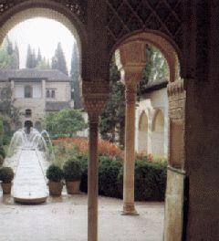

A number of musical instruments used in classical music, particularly in Spanish
music, are believed to have been derived from Arabic musical instruments used in Al-Andalus: the lute was derived from the al'ud, the rebec (ancestor of violin) from the rebab, the guitar from qitara, naker from naqareh, adufe from al-duff, alboka from al-buq, anafil from al-nafir, exabeba from al-shabbaba (flute), atabal (bass drum) from al-tabl, atambal from al-tinbal,[90] the balaban, the castanet from kasatan, sonajas de azófar from sunuj al-sufr, the conical bore wind instruments,[91] the xelami from the sulami or fistula (flute or musical pipe),[92] the shawm and dulzaina from the reed instruments zamr and al-zurna,[93] the gaita from the ghaita, rackett from iraqya or iraqiyya,[94] the harp and zither from the qanun,[95] canon from qanun, geige (violin) from ghichak,[96] and the theorbo from the tarab.[97] It is also commonly acknowledged by flamenco performers that the vocal, instrumental, and dance elements of modern flamenco were greatly influenced by the Arab performing arts.
Group 3
غياث جمول
سفيان الشوفي
وسيم الشوفي
وهاد الشوفي
up
