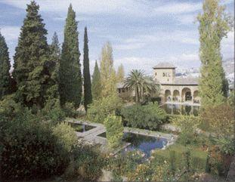
The period from the 9th century to the 13th century witnessed a fundamental transformation in agriculture that can be characterized as the Islamic green revolution in pre-modern times. The economy established in the Arab and Islamic world enabled the diffusion of many crops and farming techniques as well as the adaptation of crops and techniques from and to regions beyond the Islamic world. These introductions, along with an increased mechanization of agriculture, led to major changes in economy, population distribution, vegetation cover, agricultural production and income, population levels, urban growth, the distribution of the labour force, linked industries, cooking, diet and clothing in the Islamic world. This article presents a survey on those issues and others, such as agricultural machinery water Management and farming manuals.
Irrigation systems imported from Syria and Arabia turned the dry plains... into an agricultural cornucopia. Olives and wheat had always grown there. The Arabs added pomegranates, oranges, lemons, aubergines, artichokes, cumin, coriander, bananas, almonds, pams, henna, woad, madder, saffron, sugar-cane, cotton, rice, figs, grapes, peaches, apricots and rice."

Group 2 up
*شادي الشوفي
*يارا المنعم
*صبا الشمعة
*يارا الشوفي
  

